|  |  |
| --- | --- |
| **Name** | Adrian Leo Pradana |
| **NPM** | 2106718344 |

1. 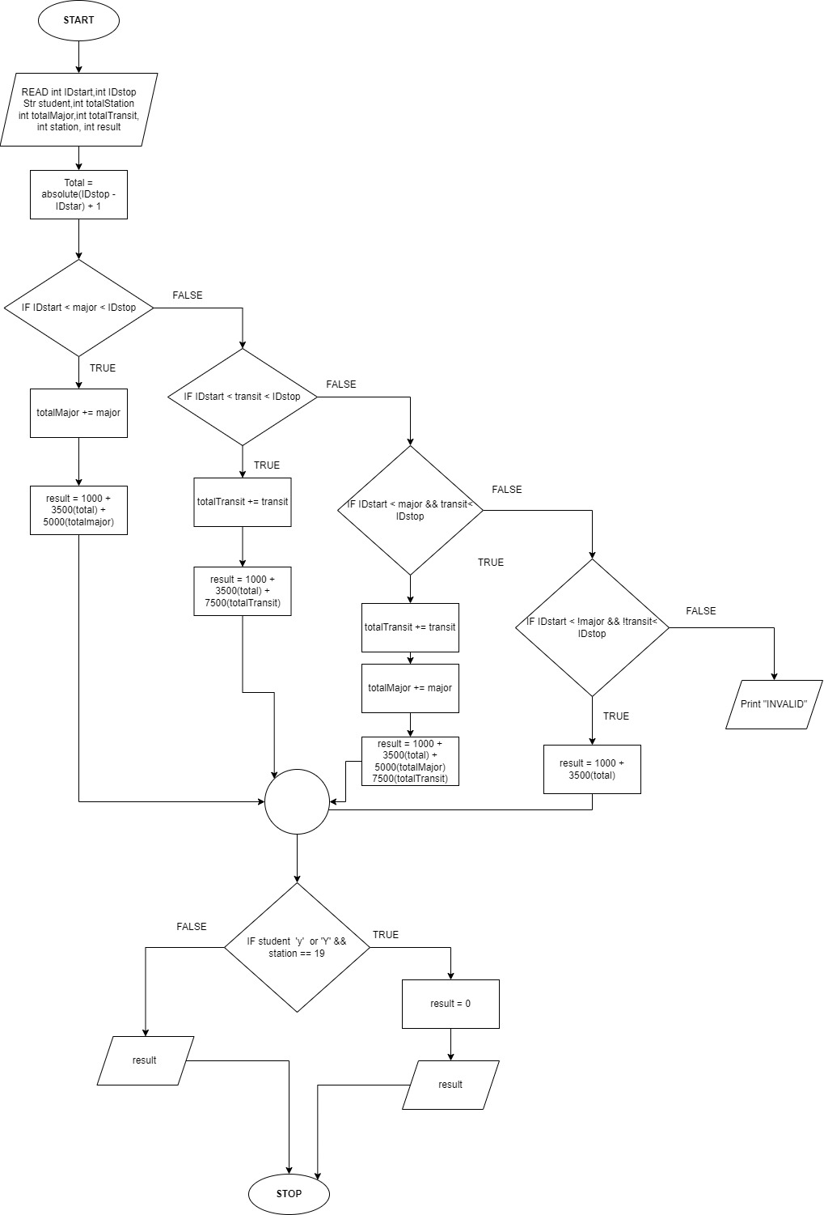

|  |  |
| --- | --- |
| **The average of three**  **integer numbers and figures out the smallest and largest numbers** | |
| 1: | **int $coin1,coin2,coin3$** ,average |
| 2: | $$Average = (coin1 + coin2 + coin3)/3$$ |
| 3: | **IF $coin1≥coin2 \&\& coin1≥coint3$** |
| 4: | **Print** “Largest number : ”,coin1 |
| 5: | **Else If $coin2≥coin1 \&\& coin2≥coin3$** |
| 6: | **Print** “Largest number :”, coin2 |
| 7: | **Else If $coin3≥coin1 \&\& coin3≥coin2$** |
| 8: | **Print** “Largest number :”, coin3 |
| 9: | **Else If $coin1≤coin2 \&\& coin1≤coin3$** |
| 10: | **Print** “Smallest Number:”, coin1 |
| 11: | **Else If $coin2≤coin3$** |
| 12: | **Print** “Smallest Number :”,coin2 |
| 13: | **Else** |
| 14: | **Print** “Smallest Number :”, coin3 |
| 15: | **EndIF** |